**Online Voting System Requirements**

**Purpose of this document:**

The first aim of this website is to caste Online Vote by sitting anywhere and by using any personal device.

**Scope of this project:**

It is a web application where people can use this application through phone or laptop. It consists of an admin who will have the control over the website. Admin can add profile of the candidate and declare the results. It will have an interface where people can cast their vote to the parties.

**Overview:**

Online Voting is a web-based voting system that will help you manage your elections easily and securely. This voting system can be used for casting votes during the election. In this system the voter do not have to go to the polling booth to cast their vote. They can use their personal computer to cast their votes. There is a database which is maintained in which all the name of the voters with their complete information is stored. The System Administrator registers the voters by simply filling a registration form to register the voters. After registration, the voter is assigned a secret voter ID with which he/she can use to login to the system and cast his/her vote. If invalid/wrong details are submitted, then the person is not registered to vote.

**User Requirements:**

1: Cast vote for a candidate

2: Declare a result

3: Admin module

**Working of E-Voting System:**

1: First there should be Home Page in which all the banners of parties are there for promotion.

2: And at the right side above there should be two options:- Login Button and Signup Button.

3: After that when user clicks on Signup Button then registration page opens and user have to fill his personal details like:- Name, Mobile No, Aadhar No, Gender, DOB, Address and Nationality.

4: After filling all these details user click on Submit Button then all his/her data stored in the Database and then Face API works and capture the image of the user and then server generate a QR Code which is downloaded automatically and saved it in the user system.

5: After that user automatically re-direct to Login Page and then there user have to enter his Aadhar No and DOB after that server ask to upload the QR Code which is generated while the user Sign in after uploading the QR Code it checks that it is valid QR or not if it is correct then user login and enter the Voting Page.

6: In Voting Page user can see the Party Symbol and Name of the Parties and at right side of each Party Name there is Voting Button when user clicks on it then Vote is casted and it shows Vote is successfully submitted and then user logout from that page and comes to Home Page.

7: After all that voting procedure there is Separate Admin Page in which Admin can manage and Declare the results but he cannot modify the results.

**Security:**

To provide security for the website we use:

1: SSL certificate

2: End to End Encryption Technique

3: To protect admin password from Brute Force, Dictionary attacks we use highly secured passwords . like:

* Minimum 8 characters long
* Must include combination of alphanumeric and special characters
* Password does not contain User Name
* Password should be not related to Family name or DOB

4: To prevent website from DOS attack we use private server with mulithreading concept.

**System Requirements:**

**OS**: Windows, Android, Linux, Ubuntu

**Ram**: 4GB

**Browser**: Chrome, Microsoft Edge

**Technologies Used:**

**Database**: MongoDB

**Server**: Apache Tomcat

**Technologies**: JAVA, Html, CSS, JavaScript, NodeJS, Blockchain, Face API

**Use Case Diagram:**

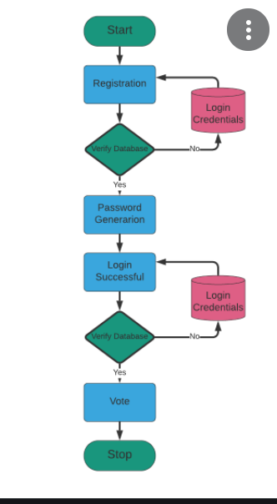

# **Conclusion:**

# From the design and implementation of the e-voting system based on the Ethereum Blockchain, conclusions can be drawn including:

# 1. The e-voting system based on the Ethereum Blockchain can work well.

# 2. This e-voting system is able to validate the voter's identity well and prevent repeating the election.

# 3. This e-voting system can store data safely and reliably.

# 4. By using this electoral system, the voting process will be much faster and safer.

# 5. The voting process and the calculation of the number of votes will be faster because the voting process is done in real-time.